**Problem Statement** : Display grades of students studying at MSIT based upon the percentage secured.

|  |  |
| --- | --- |
| **Expected Input** | **Expected Output** |
| 95  0  75  -1  80 | You got A+ Grade  You failed in the exam  You got B grade  You failed in this exam  You got B+ grade |

**Solution** :

**Pseudocode:**



\\ Main module

START

WRITE "Enter your mark "

READ num

if(num >= 95) then

WRITE " You got ex grade"

else if ( num >=90 AND num <95) then

WRITE " You got A+ grade"

else if ( num >=85 AND num <90) then

WRITE " You got A grade"

else if ( num >=80 AND num <85) then

WRITE " You got B+ grade"

else if ( num >=75 AND num <80) then

WRITE " You got B grade"

else if ( num >=70 AND num <75) then

WRITE " You got C grade"

else if ( num < 70) then

WRITE " You Failed in this exam"

ENDIF

END

**Parameters:**

* **Input: Integer number**
* **Process: if( num (check condition))**
* **Output : Prints( Grade)**

**Trace Table** :

Test Case 1: Enter Number 90

|  |
| --- |
| Asks for Input num |
| Enter 90 |
| Enters loop checks condition num>=95 |
| Condition false |
| Enters next loop, checks num between 85 , 90 |
| Print “You got A+ grade” |
| Control Flow Goes to end loop |
|  |

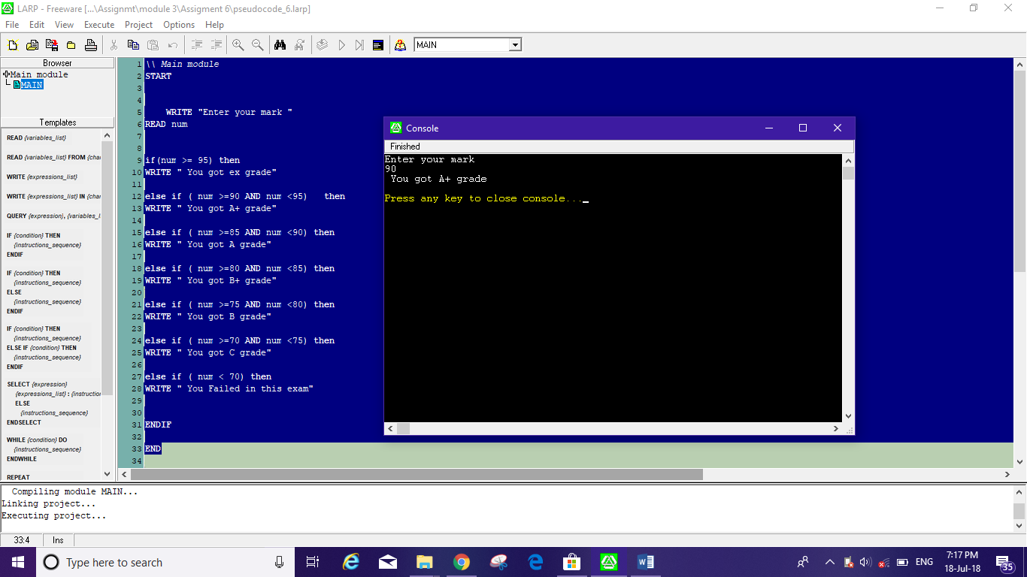

Test Case 2: Enter number 100

|  |
| --- |
| Start |
| Input Num = 100 |
| Enter loop checks condition if num>=95 |
| Print “You got EX grade” |
| Control Flow Goes to end loop |

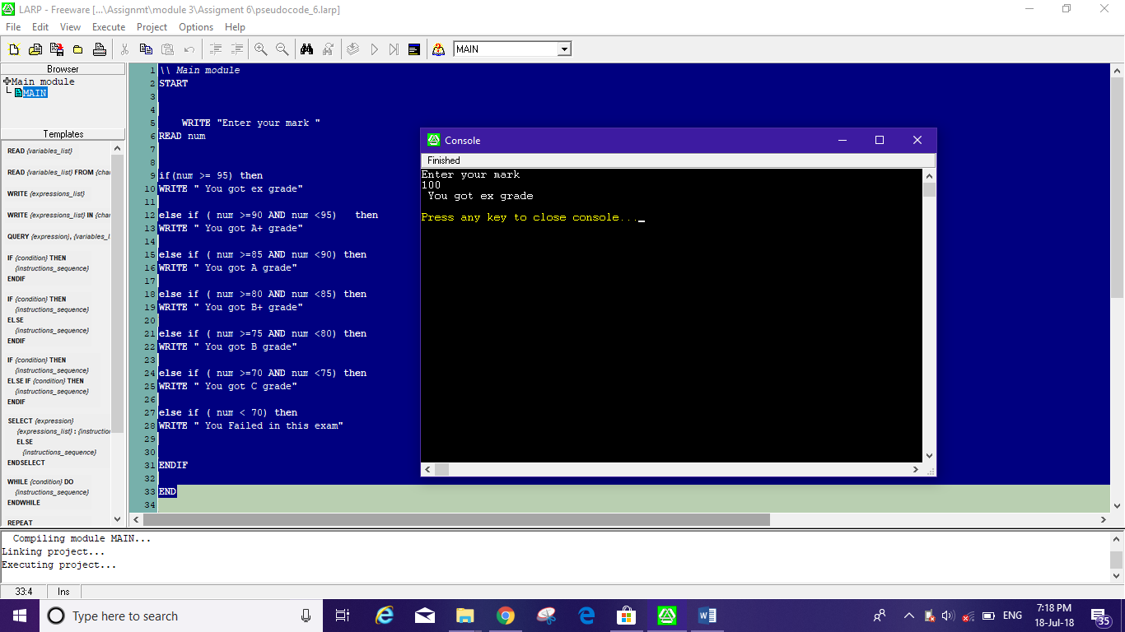

Test Case 3: Enter number 75

|  |
| --- |
| Start |
| Input Num = 0 |
| Enter loop checks condition if num>=95 |
| Return false |
| Enters next loop, checks num between 90 , 95 |
| Return false |
| Enters next loop, checks num between 85 , 90 |
| Return false |
| Enters next loop, checks num between 85 , 80 |
| Return false |
| Enters next loop, checks num >=80&&num< 75 |
| Return false |
| Enters next loop, checks num>=75&&num< 70 |
| Return true |
| Print “You got C grade” |
| Control Flow Goes to end loop |
|  |

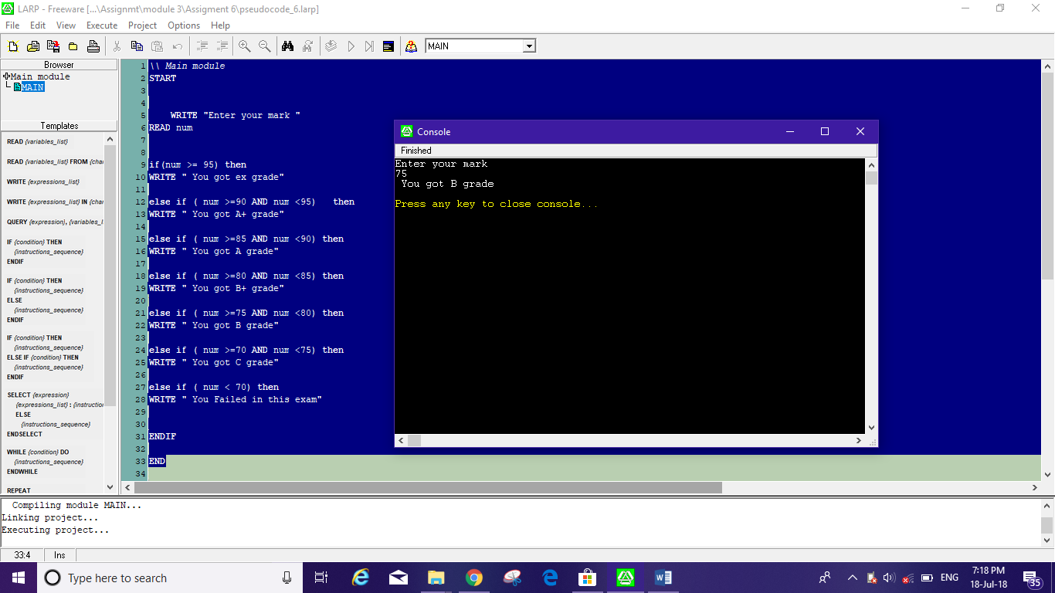

Test Case 4: Enter number 0

|  |
| --- |
| Start |
| Num = 0 |
| Enter loop checks condition if num>=95 |
| Return false |
| Enters next loop, checks num between 90 , 95 |
| Return false |
| Enters next loop, checks num between 85 , 90 |
| Return false |
| Enters next loop, checks num between 85 , 80 |
| Return false |
| Enters next loop, checks num between 80 , 75 |
| Return false |
| Enters next loop, checks num between 75 , 70 |
| Return false |
| Enters next loop, checks num less than 70 |
| Print “You failed in this exam” |
| Goes to End loop |

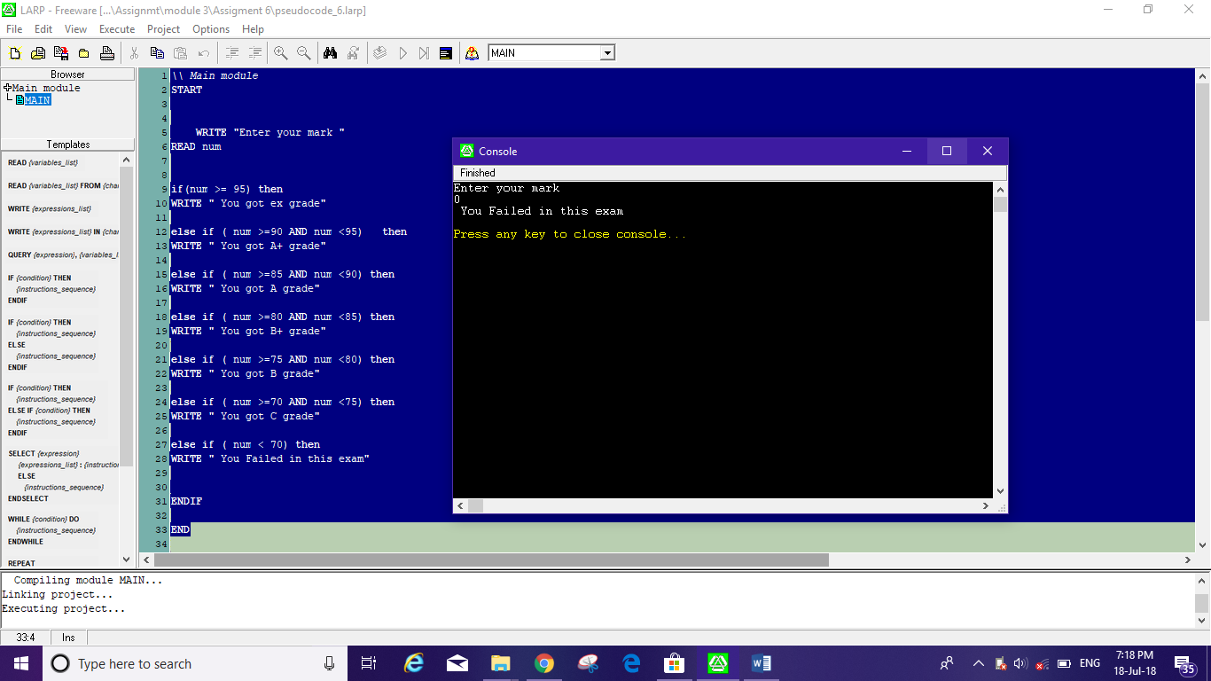

Test Case 5: Enter negative number -1

|  |
| --- |
| Start |
| Num = -1 |
| Enter loop checks condition if num>=95 |
| Return false |
| Enters next loop, checks num between 90 , 95 |
| Return false |
| Enters next loop, checks num between 85 , 90 |
| Return false |
| Enters next loop, checks num between 85 , 80 |
| Return false |
| Enters next loop, checks num between 80 , 75 |
| Return false |
| Enters next loop, checks num between 75 , 70 |
| Return false |
| Enters next loop, checks num less than 70 |
| Print “You failed in this exam” |
| Goes to End loop |

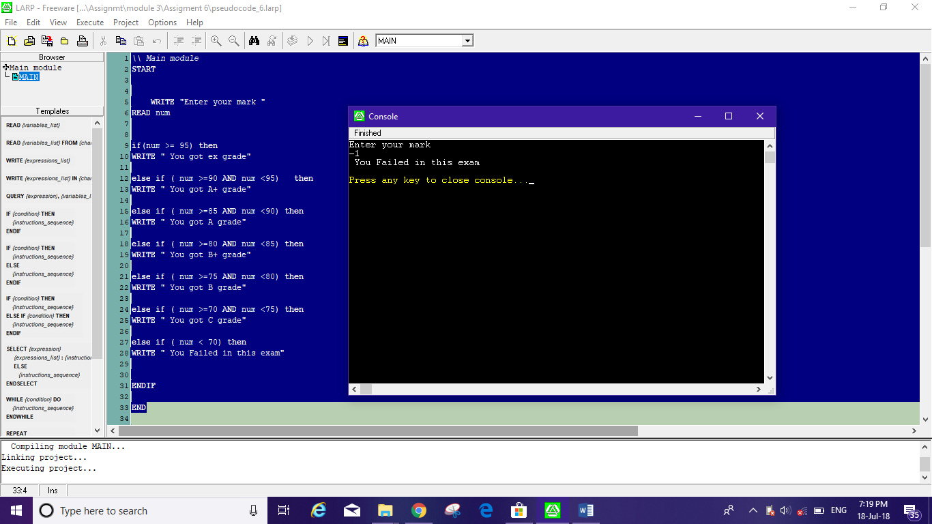

**Final Result :** **( 2 Marks)**

|  |  |  |  |
| --- | --- | --- | --- |
| **Expected input** | **Expected output** | **Actual output** | **Test result** |
|  |  |  |  |
| 95  0  75  -1  80 | You got A+ Grade  You failed in the exam  You got B grade  You failed in this exam  You got B+ grade | 95  0  75  -1  80 | You got A+ Grade  You failed in the exam  You got B grade  You failed in this exam  You got B+ grade |

**Parameters for executable code:**

Flowchart:



Test Case 1: Flowchart input: -1

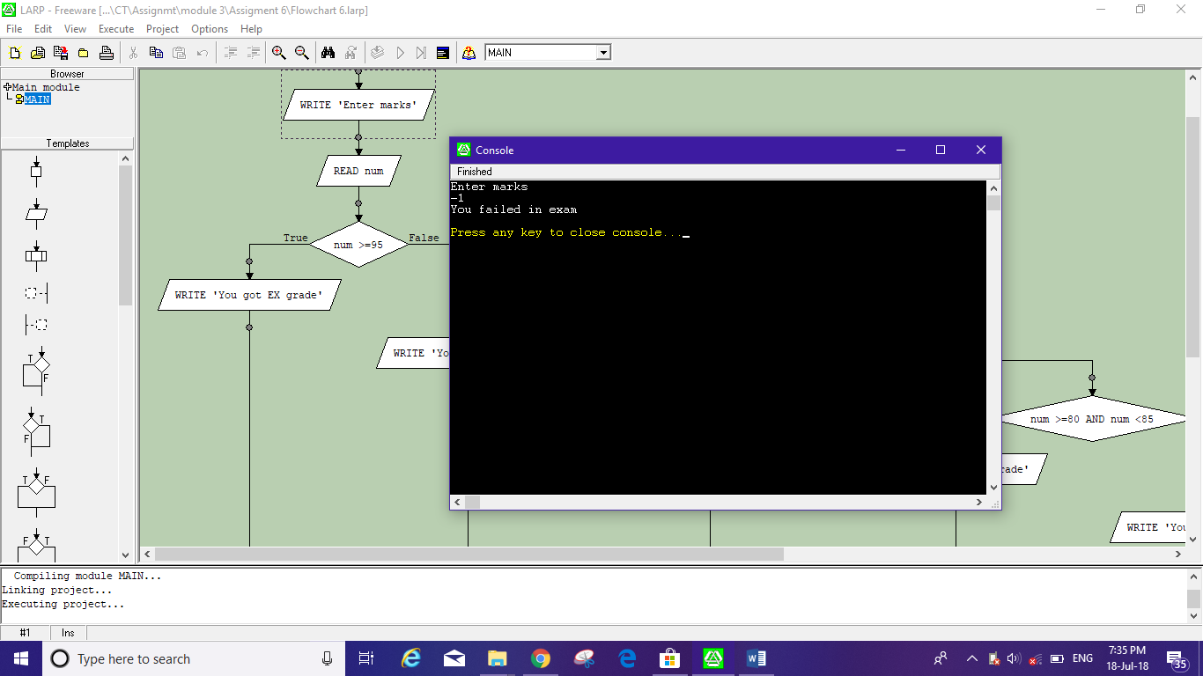

Test Case 2: Flowchart input: 80

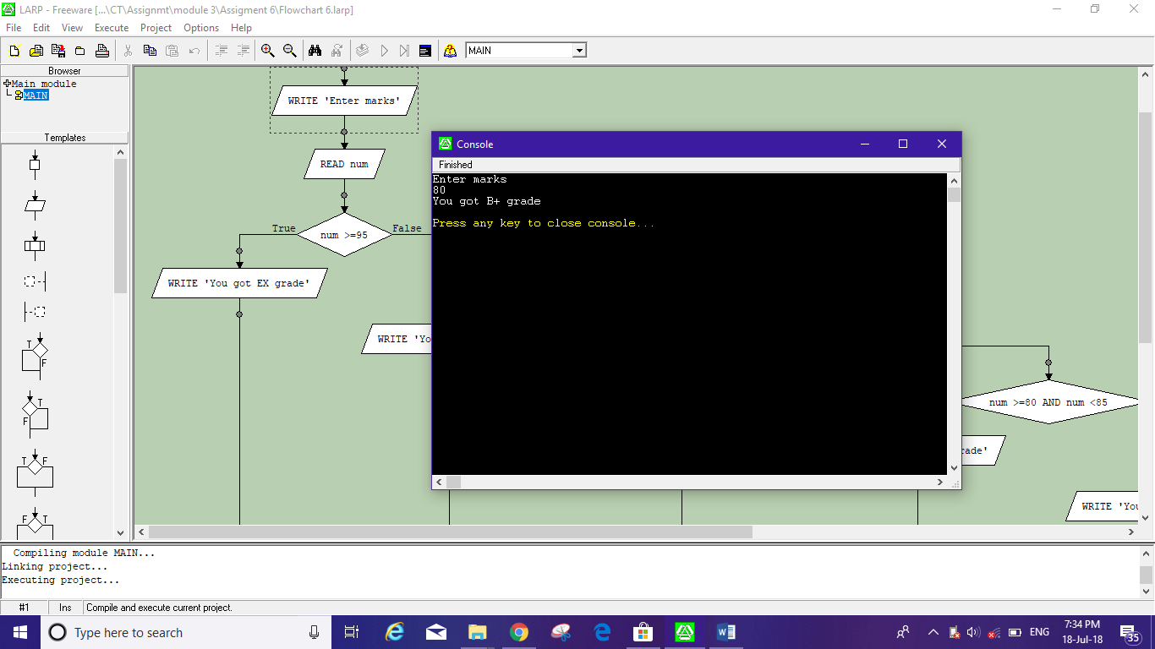

Test Case 3: Flowchart input: 0

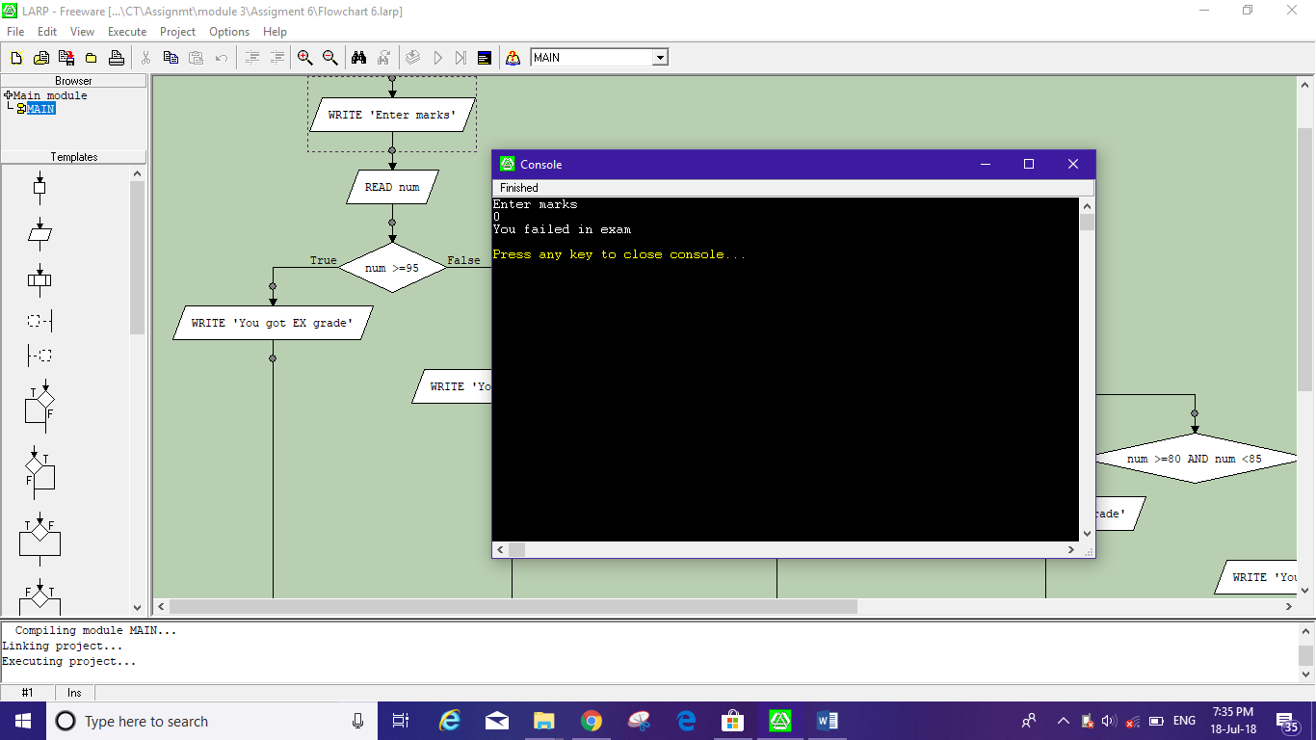

Test Case 4: Flowchart input: 75

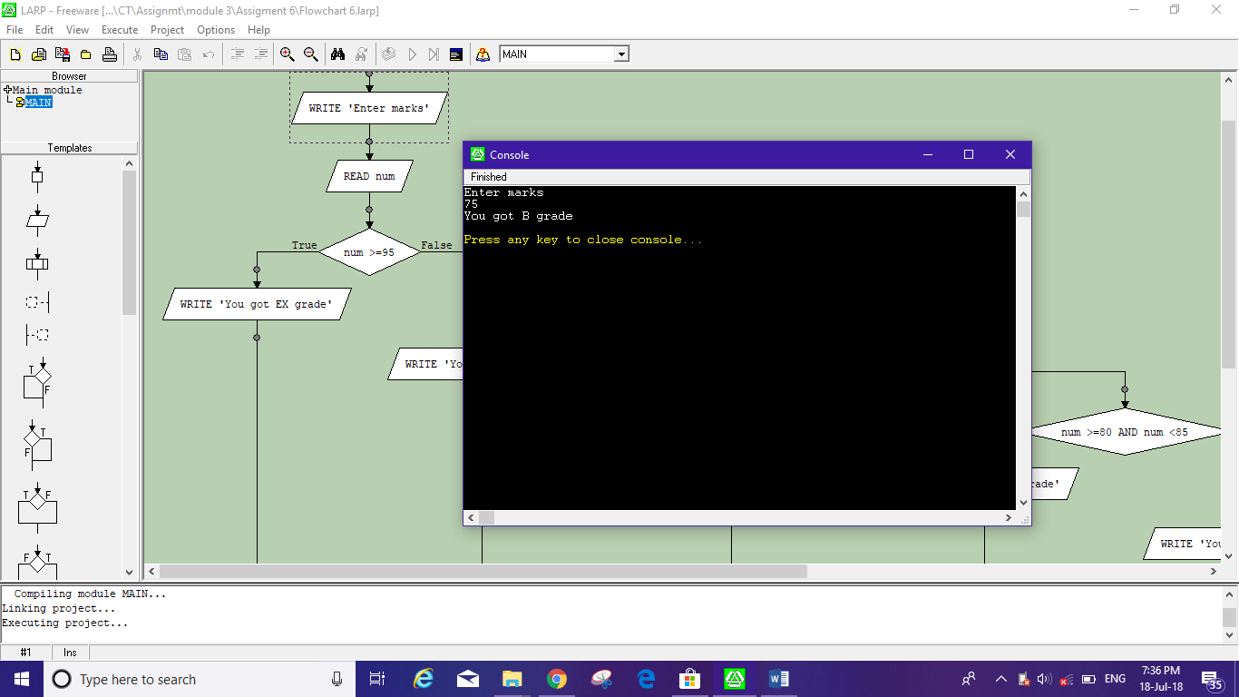

Test Case 5: Flowchart input: 60

